1. TIC-TAC-TOE
AIM
To develop a simple Tic-Tac-Toe game using Python where two players can play by manually entering their positions.
OBJECTIVE
· To implement a two-player Tic-Tac-Toe game.
· To accept manual input from the players.
· To check for a winning combination.
· To identify a draw when all positions are filled.
ALGORITHM
1. Start the program.
2. Create an empty 3×3 game board.
3. Display the board.
4. Set Player X as the first player.
5. Ask the player to enter a position from 1 to 9.
6. Place the player's symbol in the selected position.
7. Check whether the player has won.
8. If won, display the winner and stop.
9. If the board is full, display Draw and stop.
10. Otherwise, change the player and repeat.
11. Stop the program.
FLOWCHART:
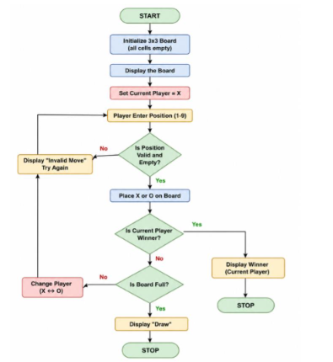
PYTHON CODE:
b = [" "]*9
def show():
print(b[0], "|", b[1], "|", b[2])
print("--+---+--")
print(b[3], "|", b[4], "|", b[5])
print("--+---+--")
print(b[6], "|", b[7], "|", b[8])
win = [(0,1,2),(3,4,5),(6,7,8),(0,3,6),(1,4,7),(2,5,8),(0,4,8),(2,4,6)]
for turn in range(9):
show()
p = "X" if turn % 2 == 0 else "O"
n = int(input(f"Player {p}, enter position (1-9): ")) - 1
if b[n] != " ":
print("Already taken!")
continue
b[n] = p
if any(b[a] == b[c] == b[d] == p for a,c,d in win):
show()
print("Player", p, "wins!")
break
else:
show()
print("Draw!")
OUTPUT:
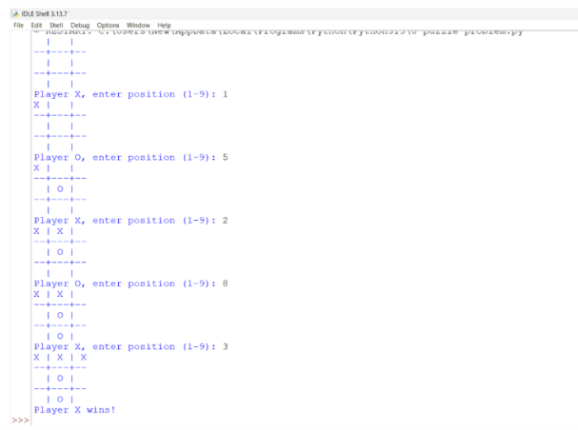
RESULT:
Thus, the Tic-Tac-Toe game was successfully implemented in Python using manual input. The program correctly identifies the winner or declares a draw.

